11/20/2021

Mobile Application Development

Lab5 Manual

Safdar Hussain, BSCS-VII-A

CMS: 023-18-0059

Activity 1

Code

MainActivity.Java

package com.example.lab5;  
  
import androidx.appcompat.app.AppCompatActivity;  
  
import android.os.Bundle;  
import android.view.Menu;  
  
public class MainActivity extends AppCompatActivity {  
  
 @Override  
 protected void onCreate(Bundle savedInstanceState) {  
 super.onCreate(savedInstanceState);  
 setContentView(R.layout.*activity_menu*);  
 }  
  
 @Override  
 public boolean onCreateOptionsMenu(Menu menu) {  
 getMenuInflater().inflate(R.menu.*menubar*, menu);  
 return true;  
 }  
}

menubar.xml

*<?*xml version="1.0" encoding="utf-8"*?>*<menu xmlns:android="http://schemas.android.com/apk/res/android"  
 xmlns:app="http://schemas.android.com/apk/res-auto">  
  
 <item  
 android:id="@+id/menu_bar"  
 app:showAsAction="always"  
 android:title="Home">  
  
 </item>  
  
 <item  
 android:id="@+id/help"  
 app:showAsAction="always"  
 android:title="Help">  
  
 </item>  
  
 <item  
 android:id="@+id/logout"  
 app:showAsAction="always"  
 android:title="Logout">  
  
 </item>  
  
</menu>

Output:

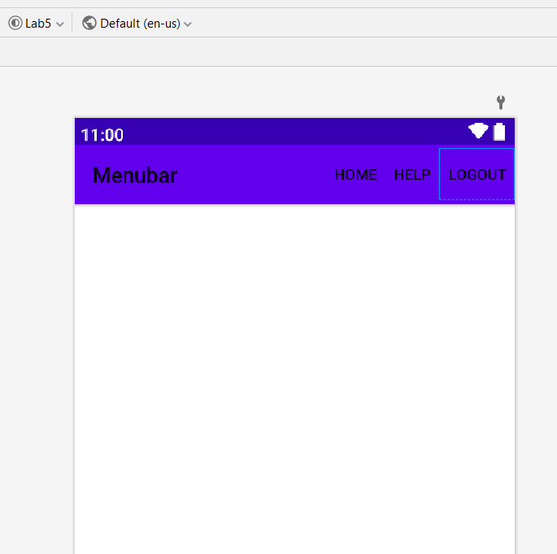

**Activity 2 : Create floating context menu and Contextual Action Bar**

• Task 1 : Create an app with a single picture in center, on holding which the menu on left

should be created.

• Task 2 : Create a Contextual Action Bar shown on right side of the picture.

package com.example.lab5;  
  
import androidx.appcompat.app.AppCompatActivity;  
  
import android.os.Bundle;  
import android.view.ContextMenu;  
import android.view.KeyEvent;  
import android.view.Menu;  
import android.view.View;  
import android.widget.ImageView;  
  
public class MainActivity extends AppCompatActivity {  
 ImageView img;  
 @Override  
 protected void onCreate(Bundle savedInstanceState) {  
 super.onCreate(savedInstanceState);  
 setContentView(R.layout.*activity_menu*);  
 img = findViewById(R.id.*imageView*);  
 registerForContextMenu(img);  
  
 }  
  
 @Override  
 public boolean onCreateOptionsMenu(Menu menu) {  
 getMenuInflater().inflate(R.menu.*menubar*, menu);  
 return true;  
 }  
  
 @Override  
 public void onCreateContextMenu(ContextMenu menu, View v, ContextMenu.ContextMenuInfo menuInfo) {  
 getMenuInflater().inflate(R.menu.*context_menu*,menu);  
 super.onCreateContextMenu(menu, v, menuInfo);  
 }  
}

Output

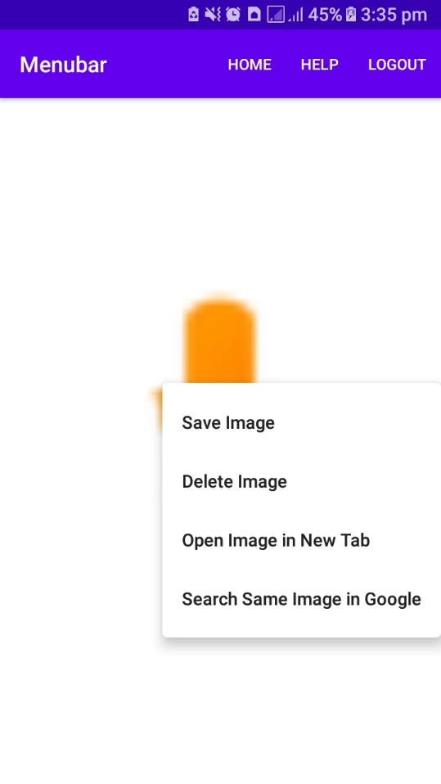

Activity 2.2

package com.example.lab5;  
  
import androidx.appcompat.app.AppCompatActivity;  
import androidx.appcompat.view.ActionMode;  
  
import android.os.Bundle;  
import android.view.ContextMenu;  
import android.view.KeyEvent;  
import android.view.Menu;  
import android.view.MenuItem;  
import android.view.View;  
import android.widget.ImageView;  
import android.widget.Toast;  
  
public class MainActivity extends AppCompatActivity {  
 ImageView img;  
 private ActionMode mActionMode;  
 @Override  
 protected void onCreate(Bundle savedInstanceState) {  
 super.onCreate(savedInstanceState);  
 setContentView(R.layout.*activity_menu*);  
 img = findViewById(R.id.*imageView*);  
 img.setOnLongClickListener(new View.OnLongClickListener() {  
 @Override  
 public boolean onLongClick(View v) {  
 if(mActionMode != null){  
 return false;  
 }  
 mActionMode = startSupportActionMode(mActionMOdeCallback);  
 return true;  
 }  
 });  
  
 *//registerForContextMenu(img);* }  
  
 private ActionMode.Callback mActionMOdeCallback = new ActionMode.Callback() {  
 @Override  
 public boolean onCreateActionMode(ActionMode mode, Menu menu) {  
 mode.getMenuInflater().inflate(R.menu.*contextual_action_menu*, menu);  
 mode.setTitle("Choose Options");  
  
 return true;  
 }  
  
 @Override  
 public boolean onPrepareActionMode(ActionMode mode, Menu menu) {  
 return false;  
 }  
  
 @Override  
 public boolean onActionItemClicked(ActionMode mode, MenuItem item) {  
 switch (item.getItemId()){  
 case R.id.*delete*:  
 Toast.*makeText*(MainActivity.this, "Delete was Selected", Toast.*LENGTH_SHORT*).show();  
 mode.finish();  
 return true;  
 case R.id.*edit*:  
 Toast.*makeText*(MainActivity.this, "Edit was Selected", Toast.*LENGTH_SHORT*).show();  
 mode.finish();  
 return true;  
 case R.id.*share*:  
 Toast.*makeText*(MainActivity.this, "Share was Selected", Toast.*LENGTH_SHORT*).show();  
 mode.finish();  
 return true;  
 case R.id.*save*:  
 Toast.*makeText*(MainActivity.this, "Save was Selected", Toast.*LENGTH_SHORT*).show();  
 mode.finish();  
 return true;  
 default:  
 return false;  
 }  
  
 }  
  
 @Override  
 public void onDestroyActionMode(ActionMode mode) {  
 mActionMode = null;  
  
 }  
 };  
  
 @Override  
 public boolean onCreateOptionsMenu(Menu menu) {  
 getMenuInflater().inflate(R.menu.*menubar*, menu);  
 return true;  
 }  
  
 */*@Override  
 public void onCreateContextMenu(ContextMenu menu, View v, ContextMenu.ContextMenuInfo menuInfo) {  
 getMenuInflater().inflate(R.menu.context_menu,menu);  
 super.onCreateContextMenu(menu, v, menuInfo);  
 }*/*}

Output:



**Activity 3: Create the menu bar shown in below picture**

package com.example.lab5;  
  
import android.os.Bundle;  
import android.view.ContextMenu;  
import android.view.KeyEvent;  
import android.view.Menu;  
import android.view.MenuItem;  
import android.view.View;  
import android.widget.Button;  
import android.widget.ImageView;  
import android.widget.TextView;  
import android.widget.Toast;  
  
public class MainActivity extends AppCompatActivity {  
 ImageView img;  
 Button longClickbtn;  
 private ActionMode mActionMode;  
 @Override  
 protected void onCreate(Bundle savedInstanceState) {  
 super.onCreate(savedInstanceState);  
 setContentView(R.layout.*activity_menu*);  
 img = findViewById(R.id.*imageView*);  
 longClickbtn = findViewById(R.id.*button*);  
 img.setOnLongClickListener(new View.OnLongClickListener() {  
 @Override  
 public boolean onLongClick(View v) {  
 if(mActionMode != null){  
 return false;  
 }  
 mActionMode = startSupportActionMode(mActionMOdeCallback);  
 return true;  
 }  
 });  
  
 registerForContextMenu(longClickbtn);  
  
 }  
  
 @Override  
 public boolean onCreateOptionsMenu(Menu menu) {  
 getMenuInflater().inflate(R.menu.*menubar*, menu);  
 return true;  
 }  
  
}

Output:

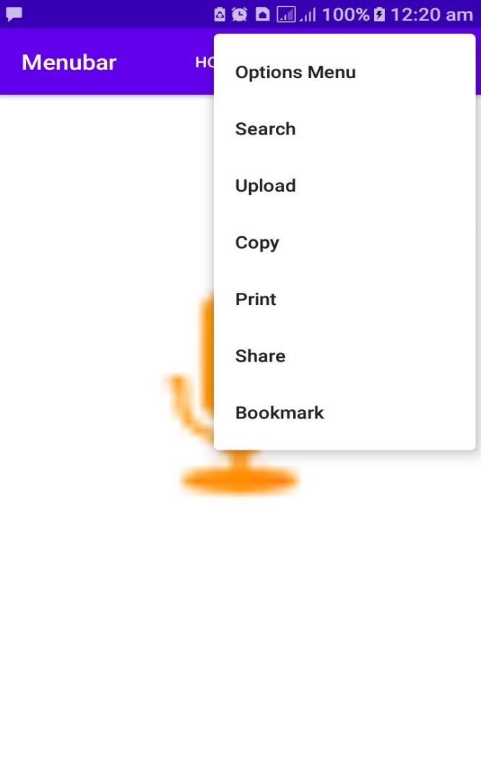

**Activity 4: Create context menu shown below**

package com.example.lab5;  
  
import androidx.appcompat.app.AppCompatActivity;  
import androidx.appcompat.view.ActionMode;  
  
import android.os.Bundle;  
import android.view.ContextMenu;  
import android.view.KeyEvent;  
import android.view.Menu;  
import android.view.MenuItem;  
import android.view.View;  
import android.widget.Button;  
import android.widget.ImageView;  
import android.widget.TextView;  
import android.widget.Toast;  
  
public class MainActivity extends AppCompatActivity {  
 ImageView img;  
 Button longClickbtn;  
 private ActionMode mActionMode;  
 @Override  
 protected void onCreate(Bundle savedInstanceState) {  
 super.onCreate(savedInstanceState);  
 setContentView(R.layout.*activity_menu*);  
 img = findViewById(R.id.*imageView*);  
 longClickbtn = findViewById(R.id.*button*);  
 img.setOnLongClickListener(new View.OnLongClickListener() {  
 @Override  
 public boolean onLongClick(View v) {  
 if(mActionMode != null){  
 return false;  
 }  
 mActionMode = startSupportActionMode(mActionMOdeCallback);  
 return true;  
 }  
 });  
  
 registerForContextMenu(longClickbtn);  
  
 }  
  
 private ActionMode.Callback mActionMOdeCallback = new ActionMode.Callback() {  
 @Override  
 public boolean onCreateActionMode(ActionMode mode, Menu menu) {  
 mode.getMenuInflater().inflate(R.menu.*contextual_action_menu*, menu);  
 mode.setTitle("Choose Options");  
  
 return true;  
 }  
  
 @Override  
 public boolean onPrepareActionMode(ActionMode mode, Menu menu) {  
 return false;  
 }  
  
 @Override  
 public boolean onActionItemClicked(ActionMode mode, MenuItem item) {  
 switch (item.getItemId()){  
 case R.id.*delete*:  
 Toast.*makeText*(MainActivity.this, "Delete was Selected", Toast.*LENGTH_SHORT*).show();  
 mode.finish();  
 return true;  
 case R.id.*edit*:  
 Toast.*makeText*(MainActivity.this, "Edit was Selected", Toast.*LENGTH_SHORT*).show();  
 mode.finish();  
 return true;  
 case R.id.*share*:  
 Toast.*makeText*(MainActivity.this, "Share was Selected", Toast.*LENGTH_SHORT*).show();  
 mode.finish();  
 return true;  
 case R.id.*save*:  
 Toast.*makeText*(MainActivity.this, "Save was Selected", Toast.*LENGTH_SHORT*).show();  
 mode.finish();  
 return true;  
 default:  
 return false;  
 }  
  
 }  
  
 @Override  
 public void onDestroyActionMode(ActionMode mode) {  
 mActionMode = null;  
  
 }  
 };  
  
 @Override  
 public boolean onCreateOptionsMenu(Menu menu) {  
 getMenuInflater().inflate(R.menu.*menubar*, menu);  
 return true;  
 }  
  
 @Override  
 public void onCreateContextMenu(ContextMenu menu, View v, ContextMenu.ContextMenuInfo menuInfo) {  
 getMenuInflater().inflate(R.menu.*context_menu*,menu);  
 super.onCreateContextMenu(menu, v, menuInfo);  
 }  
  
  
}

Output:

